**Lab 6 Submittal**

**Step 1: Create a Database File**

**Step 2: Open a new MS Visual Studio Empty Web Project**

Selecting ASP.NET WEB Application

Selecting an empty project

**Step 3: Add a New Web Form**

**Step 4: Add Code to the Web Form File**

**Step 5: Test the Server – Side Application**

After running the application

After creating a table named Guests

**Step 6: Create a New Web Form**

After running the given code block

**Step 7: Populate the Guests Table**

As we can see the above dialog which says “Data Recorded” after clicking on Insert indicates that the data has been stored.

Similarly, I inserted 5 records.

**Step 8: Create a New Web Form**

Step 9: Test the Search Web Form

**Step 10: Add a New Web Form to your Hotel Application.**

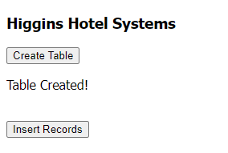

**Step 11: Open MS Access and Populate the Staff Table**

**Step 12: Add a New Web Form to your Application.**

**Step 13: Test your Application.**

**Step 14: Questions and Reflections concerning this Database project.**

(1)

There are differences between AWS and Microsoft Azure's cloud service architectures.

AWS:

AWS is distinguished by its modular architecture, which offers consumers broad flexibility and scalability over an international infrastructure. It provides a wide range of customized services that let users choose and pay for particular features.

Azure:

Microsoft Azure, on the other hand, places a strong emphasis on integration and serves companies who are heavily dependent on Microsoft products. Its architecture places an emphasis on a single platform that unifies several services and encourages seamless interoperability with Windows-based applications. When it comes to hybrid cloud solutions, Azure shines, making the integration of cloud and on-premises systems easier.

A company's current infrastructure, preferred technologies, and the degree of customisation or integration needed for their apps all play a role in the choice between the two.

(2)

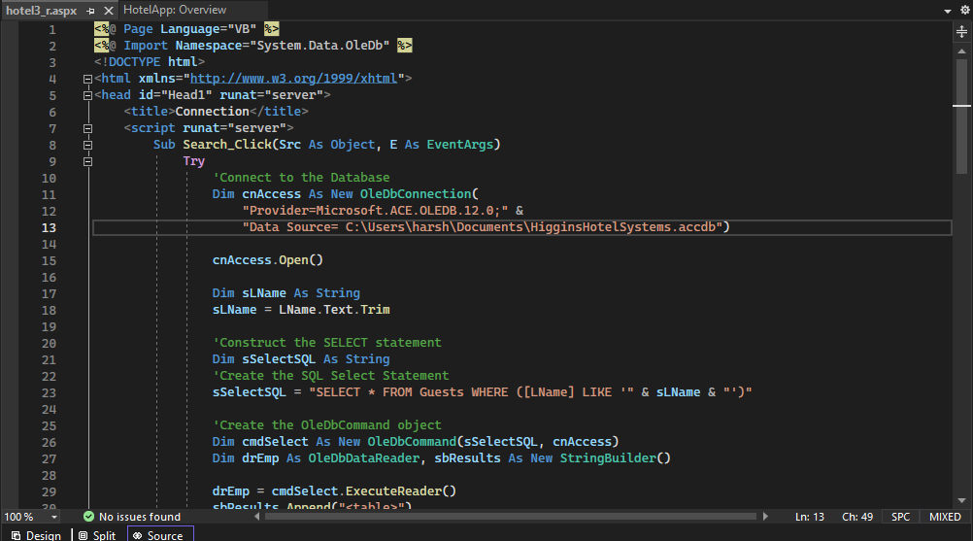

I will add a cancellation button for the reservation to be cancelled. We can search the reservation made based on the last name and according to that we can cancel the reservation.

(3)

1. Inputs required to do the reservation is:

Firstly, we need to give Location.

Then Check-in and Check-out date.

Then room and guest count.

Then select best available rate if special rate is available.

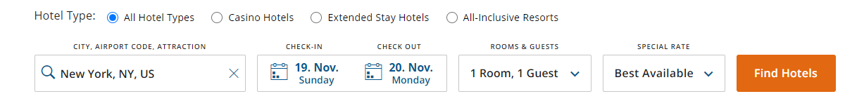

1. After the inputs are provided:

We get hotels in that location.

Then we can filter according to our exact location preferences.

Then we can filter according to our needs such as swimming pool, free Wi-Fi, smoking free, parking, distance from the airport, etc.

(4)

In both hotel reservation and educational registration systems, similarities exist in various components. Personal information, reservation/course details, payment data, and confirmation receipts are typical input elements in both hotel reservation and educational registration systems. Databases including consumer and student data, registration and reservation records, and financial transaction logs are examples of comparable files. Database and file servers are needed for storage, and local and wide area networks are part of the network architecture, which guarantees safe connections for data transmission. These systems share the core components—data storage, network connectivity, and input requirements—necessary for managing reservations and enrollments and enabling seamless operations in both hospitality and educational environments, despite variations in scale and particular specifics.

(5)

Generally speaking, organized data is advised for a reservation system. Structured data fits nicely into tables or databases, is arranged, and adheres to a specified structure. This is why it is better to have structured data:

**1. Query Efficiency**: Quicker and simpler querying is made possible by structured data. Rapid access to data, such as available rooms or courses, client information, and booking history, is essential in a reservation system. The systematic nature of structured data makes these searches easier to use.

**2. Consistency and Reliability**: Data in a predetermined format is more reliable and consistent, and error-prone data is less likely. Accuracy in a reservation system is essential. Financial records, reservation details, and client information are all uniformly stored thanks to structured data.

**3. Integration and Analysis**: Analytical tools and system integration are made easier with structured data. It makes it simple to integrate with analytics platforms, CRM systems, and payment gateways, promoting a deeper comprehension of consumer behavior and preferences.

**4. Scalability and Maintenance:** Structured data is more scalable since reservation systems frequently handle enormous amounts of data. Databases and systems scale more easily when the data is organized in a systematic manner. Additionally, upgrades and maintenance are simpler.

While handling a variety of data types, such as emails, images, and social media content, is one advantage of unstructured data, for a reservation system that focuses on customer information, bookings, and financial transactions, the structured format offers the efficiency and organization required for efficient system operation.